**192111610**

**A.Ravi**

**16.Create a Cloning of a VM and Test it by loading the Previous Version/Cloned VM**

Original VM:

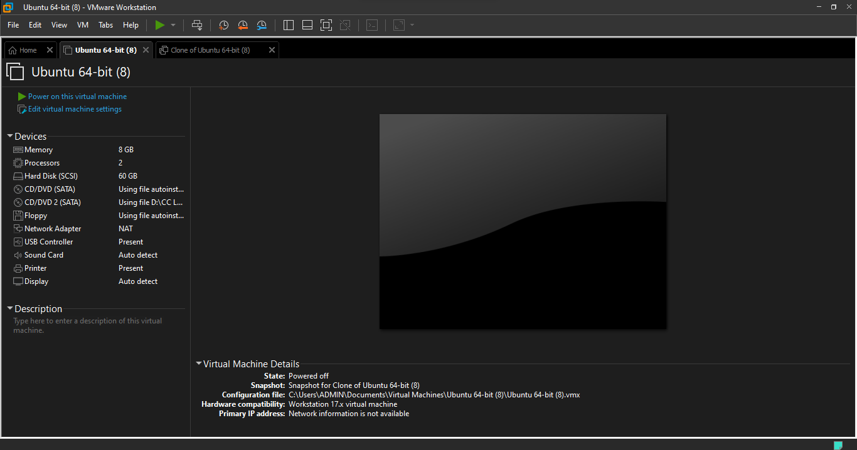

Cloned VM:

